
Measuring what matters: tracking climate adaptation processes and outcomes for smallholder producers in the agriculture sector

Deliverable 5: Systematic Map

June 2026, v02

Jennifer Denno Cissé*, jenn@bristlep.com, USA, Bristlepine Resilience Consultants
Zarrar Khan, zarrar@bristlep.com, USA, Bristlepine Resilience Consultants
Caroline G. Staub, caroline@bristlep.com, USA, Bristlepine Resilience Consultants

Keywords: Climate Adaptation, Adaptation Outcomes, Adaptation Process, Smallholder Farmers, Monitoring and Evaluation (M&E), Agriculture

1. Key findings
This document presents a systematic map of methods used to track and measure climate adaptation processes and outcomes for smallholder producers in LMICs. This report is based on 151 studies coded across nine batches (those included after full-text screening of a randomly selected 18 0 papers). Seven findings stand out:
- Rigorous experimental approaches (like randomized control trials) and modeling with empirical validation are exceptionally rare: Only 7 % of coded studies use experimental designs. Quantitative and qualitative methods dominate. The evidence base can describe what was implemented but cannot prove whether it improved outcomes.

- Producer bias: Adaptation research overwhelmingly targets crop farmers. Fisheries/aquaculture and agroforestry account for 12 % of producer-type tags combined. These producer systems, critical across tropical LMICs, are nearly invisible in the evidence base.
- Institutional governance appears in only 18 of 604 study-domain instances (151 studies) across all producer types: The systemic conditions that determine whether adaptation reaches people are almost entirely unmeasured. Access to services appears in only 35 of 604 instances (151 studies).
- Highly vulnerable groups remain largely underrepresented in the literature: 39% of coded studies do not specifically target marginalized groups. Where they do, it is mostly women, indigenous peoples and youth. Disability, ethnic minorities, and the elderly appear in fewer than 2 studies each; indigenous peoples in 6 studies.
- Process over outcomes: Knowledge, adoption, and decision-making account for the majority of the evidence base. Income, wellbeing, resilience, and other impact outcomes are substantially underrepresented by comparison.
- Studies are heavily concentrated in Sub-Saharan Africa and South Asia. Ethiopia, Ghana, and Kenya alone account for 22% of all human-coded studies. Large evidence gaps persist across Central America, Southeast Asia, the Sahel, and MENA.

2. Background
A growing number of climate adaptation interventions and autonomous adaptation are being deployed across the agriculture sector to support smallholder producers in LMICs. Despite growing investment, a central challenge persists: how to measure the effectiveness of these interventions. Monitoring and evaluation (M&E) in this space is particularly complex, due to long timeframes, evolving climate baselines, terminological differences, and attribution challenges. This systematic map responds to these challenges by systematically identifying, and characterising the methods used to assess climate adaptation interventions in the agriculture sector, with a focus on smallholder producers in LMICs.

3. Methods
This systematic map was conducted in accordance with a pre-registered protocol (Cissé, Staub & Khan, 2025; https://doi.org/10.5281/zenodo.19811629), following CEE guidelines for systematic maps (Collaboration for Environmental Evidence, 2018) and reported in accordance with ROSES standards (Haddaway et al., 2018; https://doi.org/10.1186/s13750-018-0121-7) .

3.1 Search Strategy
Searches were conducted in Scopus (Elsevier) in January 2026, using a structured Boolean search string developed around the PCCM framework (Population: smallholder producers; Concept: adaptation processes and outcomes; Context: climate hazards, LMICs, agriculture sector; Methodological Focus: measurement, indicators, monitoring and evaluation approaches). Searches were restricted to literature published from 2005 onward and to English, French, and Spanish language sources. A total of 17,021 records were retrieved. The full search string is provided in the published protocol (Cissé, Staub & Khan, 2025; https://doi.org/10.5281/zenodo.19811629).
Additional databases searched in parallel include Web of Science Core Collection, CAB Abstracts, Academic Search Premier, EconLit, ProQuest, Google Scholar, and AGRIS. Grey literature was searched across 20 organisational websites and repositories, including the World Bank, GCF, GEF, IDB, ADB, AfDB, FAO, IFAD, UNDP, UNEP, UNFCCC, CGIAR (CGSpace), and the Campbell Collaboration, searched in English . Across all sources, 40,653 records were retrieved prior to deduplication. Search comprehensiveness was assessed against a pre-compiled benchmark list of 266 known relevant studies, compiled from stakeholder recommendations and IPCC AR6 Working Group II chapters. Of the 29 benchmark studies confirmed as eligible for this review, all 29 (100%) were retrieved by the Scopus search, indicating high search sensitivity prior to iterative string refinement..

3.2 Deduplication
Records from all databases were deduplicated using a multi-stage matching algorithm: exact DOI match, then exact title and year match, then fuzzy title similarity (Jaccard ≥ 0.85). Scopus records were used as the primary reference set; net-new records from other databases were identified against this base.

3.3 Screening
Title and abstract screening was conducted using a validated LLM-assisted screening tool (Ollama/qwen2.5:14b), calibrated against the PCCM eligibility criteria. Six calibration rounds were completed by two independent human reviewers prior to full-corpus screening. Reviewers screened each calibration sample independently, reconciled disagreements into a gold standard, and revised eligibility criteria iteratively between rounds. The final calibration achieved sensitivity of 0.966–0.970 and Cohen's κ = 0.72 against the reconciled gold standard . All 26,173 deduplicated records were screened at the title and abstract stage. Of these, 8,753 (33%) were included for full-text assessment and 17,420 (67%) were excluded. Studies were included and excluded according to the following eligibility criteria (Table 1)
Table 1. Eligibility Criteria
Category | Inclusion Criteria | Exclusion Criteria
Population | Studies examining climate change adaptation interventions targeting smallholder producers and related agricultural production systems—defined as individuals or households engaged in small-scale production across crops, livestock, fisheries/aquaculture, and forestry. | Studies focusing on populations other than smallholder producers, such as large-scale commercial agriculture, agribusiness value chains without a smallholder focus, or non-agricultural livelihoods.
Concept | Included studies assess or document adaptation processes or outcomes, such as changes in capacities, practices, or resilience. Studies need not explicitly use the term “adaptation,” but must describe interventions aligned with adaptation objectives (e.g., reducing climate risks, enhancing climate resilience, or improving coping capacity). | Studies that address climate change mitigation only or general development objectives without an explicit or implicit focus on climate risk, climate resilience, or adaptive capacity and therefore do not assess adaptation processes or outcomes.
Context | Studies conducted within agricultural settings in LMICs that are exposed to climate hazards or climate-stress conditions and are framed in relation to climate change, climate variability, or climate risk. Eligible contexts include crop, livestock, fisheries/aquaculture, or forestry systems where climate-related stressors (e.g., drought, flooding, temperature extremes, rainfall variability) are relevant to agricultural production and adaptation decision-making. Studies must situate interventions, outcomes, or analyses within an explicit climate–agriculture context consistent with adaptation framing. | Studies conducted outside agricultural sector domains or without reference to climate hazards, climate-stress conditions, or climate risk framing. This includes studies addressing agricultural systems without a climate dimension, climate impacts or responses unrelated to agriculture, or development or environmental studies that do not explicitly link climate stressors to agricultural production or adaptation processes.
Methodology | Studies that describe, propose, apply, or evaluate a method, tool, framework, or set of indicators intended to assess climate change adaptation processes or outcomes.  Adaptation processes: The processes of adjustments in ecological, social, or economic systems to moderate potential damages and benefit from opportunities from climate change.  Adaptation outcomes: The results of adjustments in ecological, social, or economic systems to moderate potential damages and benefit from opportunities from climate change.  Eligible studies may include conceptual or methodological frameworks, modeling or simulation studies, pilot applications, or evaluations, provided they present sufficient methodological detail to understand the structure, intended use, and measurement approach of the method (e.g., indicators, data requirements, analytical logic). | Studies that do not present a discernible method or measurement approach (e.g., purely narrative discussions, opinion pieces, or general conceptual commentary without methodological specification), or that lack sufficient detail to allow the method to be meaningfully classified or compared.
Publication Period | Published between 2005–2025, capturing contemporary adaptation evaluation methods post-IPCC AR4 (2007) and emergence of National Adaptation Programmes of Action. | Publications before 2005.
Language | English, French, or Spanish. | Other languages.
Publication Type | Academic and gray literature from reputable sources (multilateral organizations, bilateral donors, international NGOs, national research institutes, recognized evaluation units). | Unclear or non-reputable sources.
Geographic Scope | Single or multi-country studies including at least one LMIC. | Studies exclusively in high-income countries.

3.4 Coding and information saturation
Data extraction was conducted by five trained research assistants using a standardised codebook . Of the papers included for full-text screening, studies were drawn in batches of 20 (fixed integer seeds ( each batch excludes prior-batch DOIs). Coders applied the five PCCM inclusion criteria to confirm inclusion, then completed 16 extraction fields (country, scale, producer type, adaptation focus, domain, methodology, equity, etc.). A coding calibration exercise was conducted on a subset of studies (R1a) in which the research assistants independently coded the same papers; disagreements were reviewed and adjudicated by the lead reviewer to ensure consistency.
Information saturation was tracked at each batch across three dimensions: process/outcome domains (13 canonical values), methodological approaches (5), and producer types (5). All three dimensions reached saturation within the initial few batches (49 papers coded) with zero new canonical categories added across any of the six subsequent batches (99 additional papers). Across nine batches, 18 0 papers were drawn for coding; 151 met the inclusion criteria.

3.5 Evidence Map Construction
The evidence gap map was constructed as a two-dimensional matrix of process/outcome domains (rows) against producer types (columns). Thirteen canonical process and outcome domains were used as rows: seven process domains (access to information and services, behavioural change, decision-making and planning, institutional governance, knowledge and awareness, participation and co-production, and uptake and adoption) and six outcome domains (income and assets, livelihoods, resilience and adaptive capacity, risk reduction, wellbeing, and yields and productivity). Five producer types were used as columns (crop, livestock, fisheries and aquaculture, agroforestry, and mixed). Each cell represents the number of studies tagged with that domain and producer type combination; studies may appear in multiple cells where more than one domain or producer type was coded. Cells with no studies represent evidence gaps. The map was produced in both static (PNG) and interactive (HTML) formats; the interactive version is available at https://bristlepineconsulting.com/projects/ilri01/systematic-map#evidence-gap-map.

4. Final results

4.1 Search and screening summary
A total of 40,653 records were identified across eight bibliographic databases and 20 grey literature sources. After deduplication, 26,173 unique records entered title and abstract screening. The validated LLM screening tool identified 8,753 records for full-text assessment. Papers were coded in batches of 20 by research assistants. Of 18 0 papers drawn across nine batches, 151 met the inclusion criteria; additional batches are in process.
Table 2. Search and screening results by database
Database | Returned | After dedup | Abstr. incl.
Scopus | 17,021 | 17,021 | 6,218
Web of Science | 15,179 | 4,683 | 1,137
CAB Abstracts | 5,723 | 3,229 | 1,133
Academic Search Premier | 1,187 | 274 | 66
AGRIS | 3 | 1 | 1
EconLit | 479 | 263 | 83
ProQuest | 368 | 117 | 40
Google Scholar | 198 | 100 | 34
Grey literature (20 sources) | 495 | 485 | 41
Total | 40,653 | 26,173 | 8,753

Figure 1 presents the PRISMA flow diagram showing record flow across 28 sources and all screening stages.
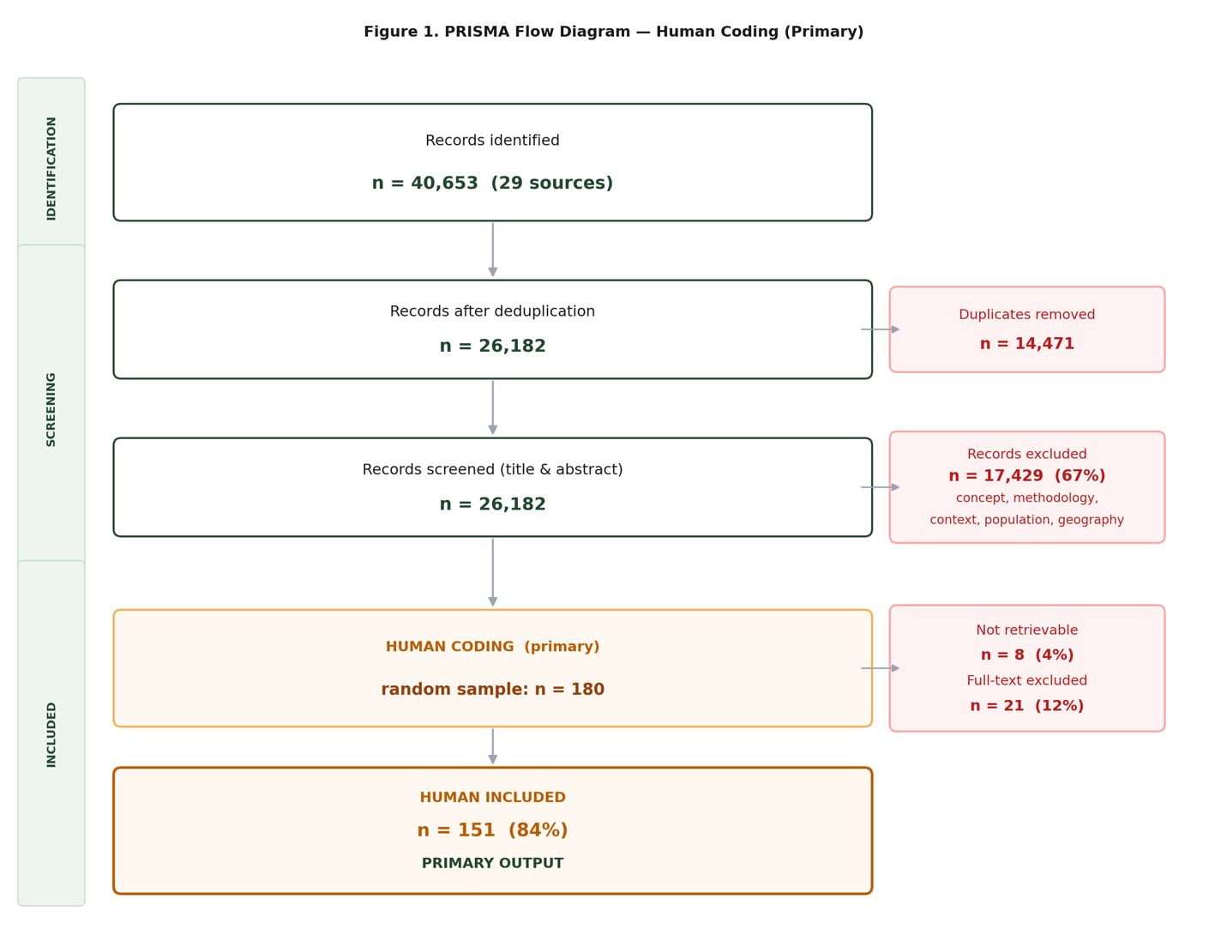
Figure 1. PRISMA flow diagram — record flow across 28 sources.

4.2 Evidence gap map
The evidence gap map (EGM) shown in Figure 2 is the primary output of this deliverable. It plots the distribution of coded studies (n = 151) across process and outcome domains (y-axis) and producer types (x-axis). Bubble size is proportional to the number of studies in each cell. Grey circles indicate evidence gaps with no studies in that combination.
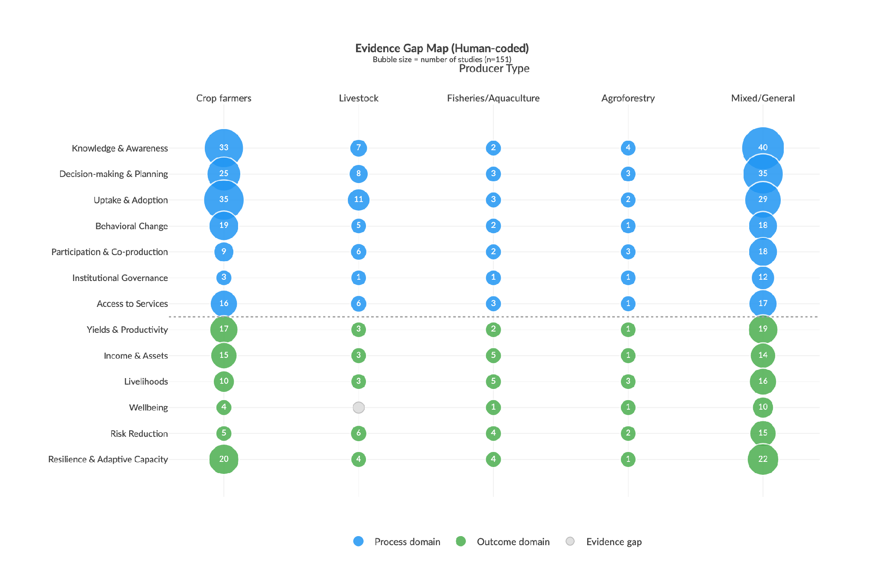Figure 2. Evidence gap map results (n = 151). Blue = process domains · green = outcome domains · grey = evidence gaps. Bubble area ∝ number of studies.
Key observations:
- Process-oriented measures dominate. Decision-making & planning, knowledge & awareness, and uptake & adoption are the most studied domains, especially for crop farmers.
- Outcome-oriented measures are nearly absent. Income & assets, wellbeing, risk reduction, and resilience are sparsely covered, and almost exclusively for crop systems. The evidence gap visualizes this limitation, showing a clustered abundance of research on whether crop farmers are trying to adapt, but limited evidence on whether these efforts are actually improving their long-term adaptive capacity and wellbeing.
- Over-representation of Crop Farmers. Non-crop producer types are systematically uncovered. Livestock, fisheries, agroforestry, and mixed-system producers appear in very few cells; most cells for these types are gaps.
- Institutional governance and access to services remain among the least-studied domains: 18 and 35 studies respectively across all producer types (18 and 35 of 604 study-domain instances).

4.3 Geographic distribution
Figure 3 (map) and Figure 4 (bar chart) show that s tudies are heavily concentrated in Sub-Saharan Africa and South Asia. Ethiopia, Ghana, and Kenya alone account for 22 % of all human-coded studies. Large evidence gaps persist across Central America, Southeast Asia, the Sahel, and MENA.

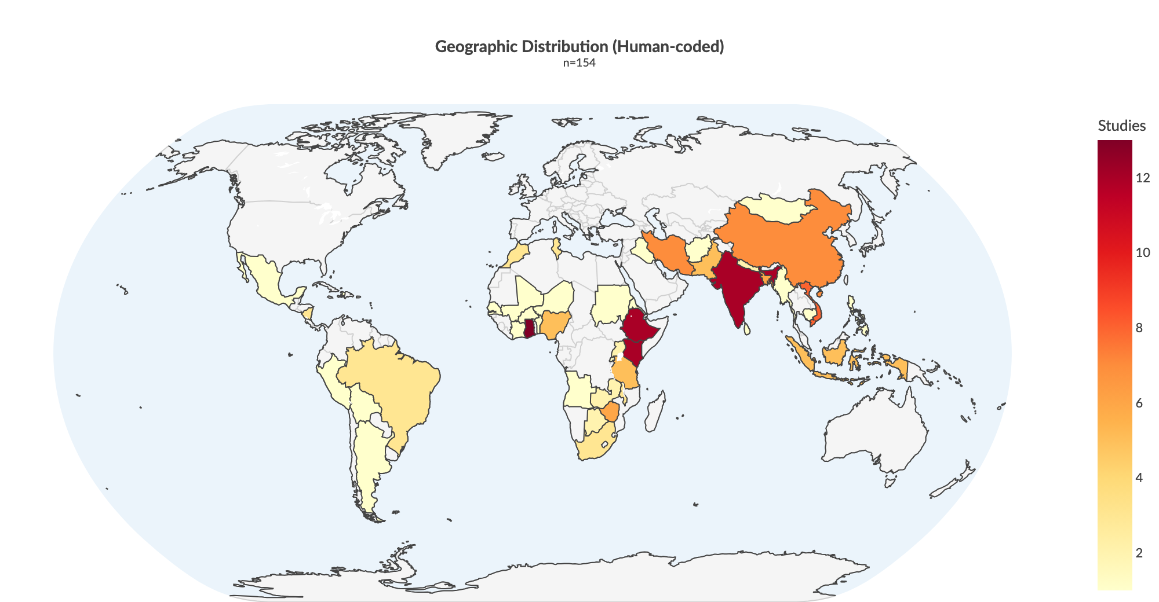
Figure 3. Geographic distribution of included studies.

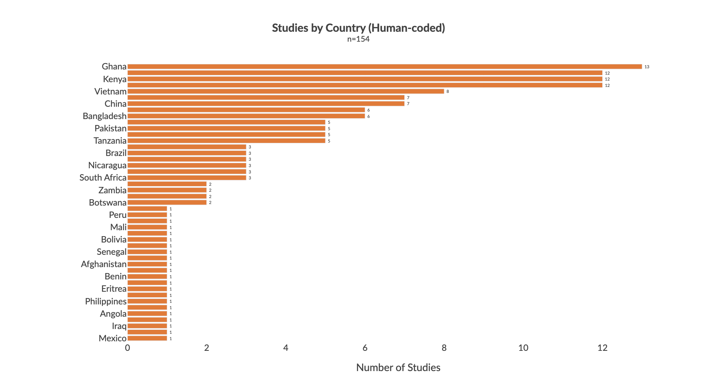
Figure 4. Top countries by study count.

4.4 Methodological approaches

Quantitative and qualitative approaches dominate the evidence base, accounting for 110 and 82 studies respectively (Figure 5). Experimental designs, including randomised controlled trials and quasi-experimental studies, represent only 8% of the corpus (12 of 151 studies), severely limiting causal inference about adaptation effectiveness. Participatory approaches are common, appearing in 25% of studies, particularly for process-level outcomes. Mixed methods and modelling are rare (4% and 9% respectively). This heavy reliance on observational approaches, and the near absence of experimental or longitudinal designs, means the current literature maps the uptake and awareness of adaptation strategies well but cannot prove whether they work.

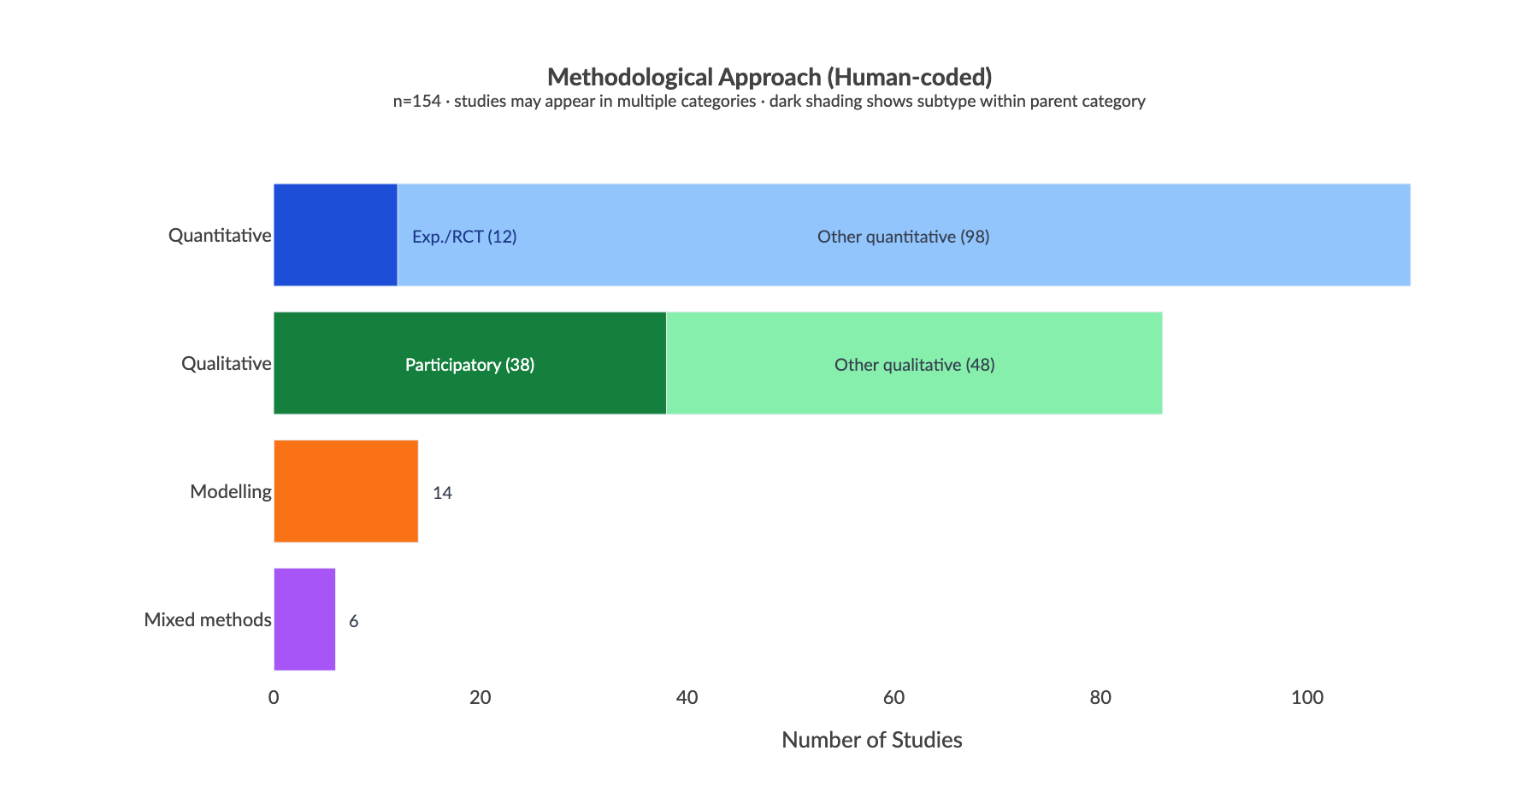
Figure 5. Methodological approaches across included studies.

4.5 Equity and inclusion
There is a significant gap in how adaptation research addresses social vulnerability. Figure 6 shows that 38% of included studies make no reference to any marginalized group. Where groups do appear, the focus is heavily skewed: women feature in ~35% of studies and youth in ~29%. Beyond these two groups, the evidence base drops sharply with indigenous peoples, landless communities, ethnic minorities, and migrant workers each appearing in fewer than 5% of studies, and people with disabilities and the elderly in fewer than 2%.
This concentration on women and youth, while valuable, masks the absence of evidence for other highly vulnerable populations. The literature largely treats smallholder farmers as a homogenous group, ignoring how intersecting vulnerabilities (disability, land tenure, ethnicity, age) shape an individual's capacity to adapt to climate shocks. Because studies rarely measure how specific subgroups respond to interventions, future climate resilience programmes risk relying on generic capacity-building models that overlook the distinct needs of the most marginalised.

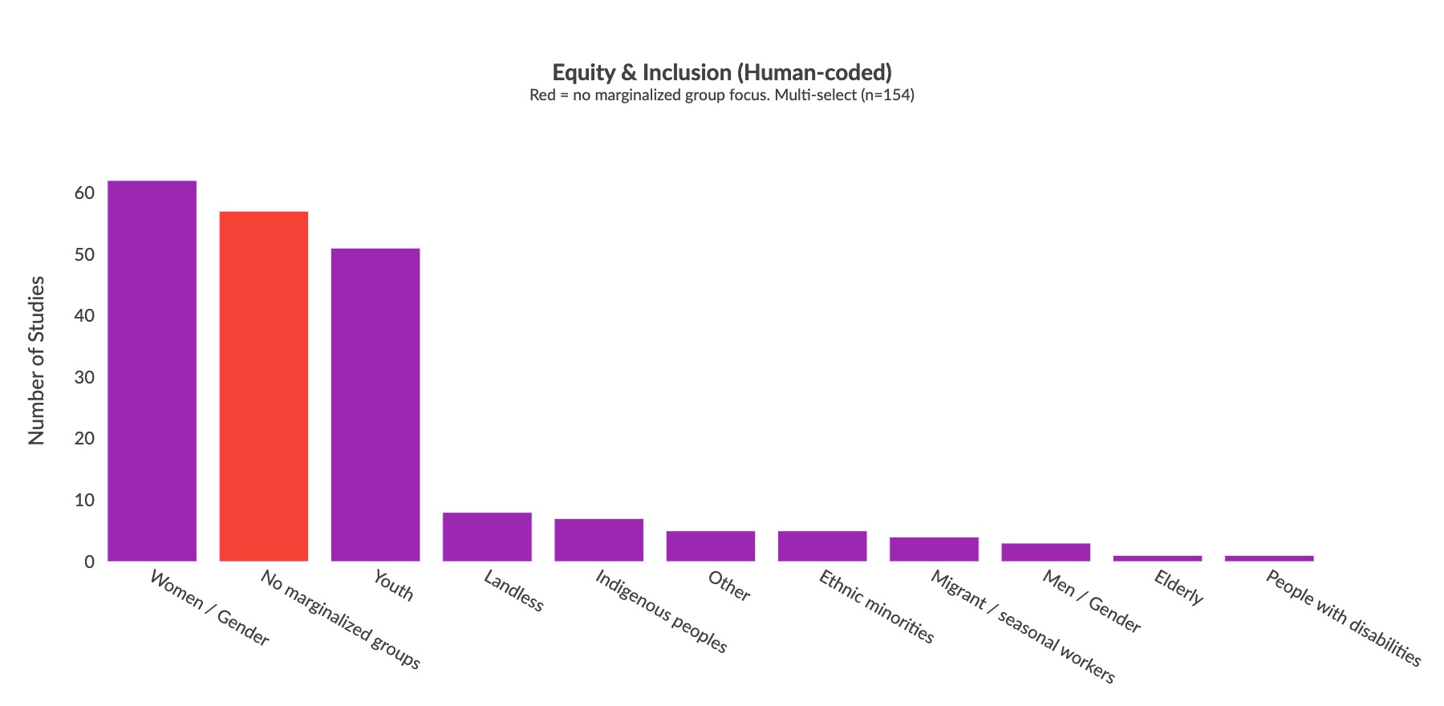
Figure 6. Equity and inclusion dimensions across included studies. Red bar = studies with no marginalized group focus.

4.6 Publication trends and saturation
Annual publications increased more than five-fold between 2005–2014 (average 2 studies per year) and 2015–2024 (average 11 per year), peaking in 2021 (Figure 7). The evidence base is almost entirely contemporary with fewer than 10% of included studies predating 2015, meaning long-term impact evidence remains very thin.

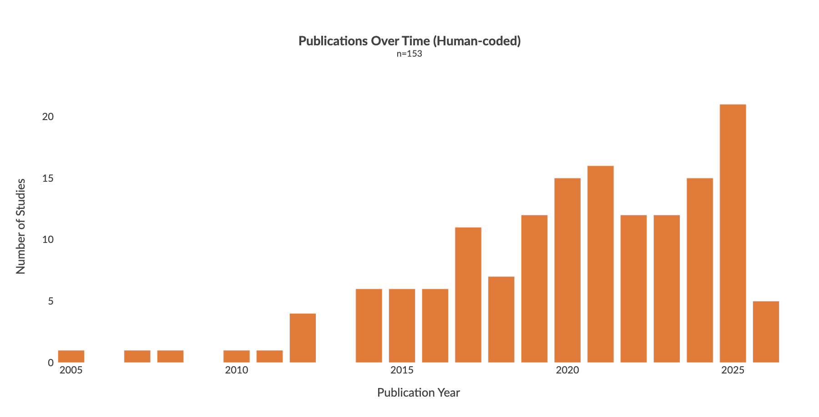
Figure 7. Publication trends across included studies.

Saturation analysis (Figure 8) shows that all three tracked dimensions (process/outcome domains, methodological approaches, and producer types) reached saturation by 49 papers. Zero new canonical categories were added in the final two batches, confirming the human-coded sample is representative of the broader evidence base.
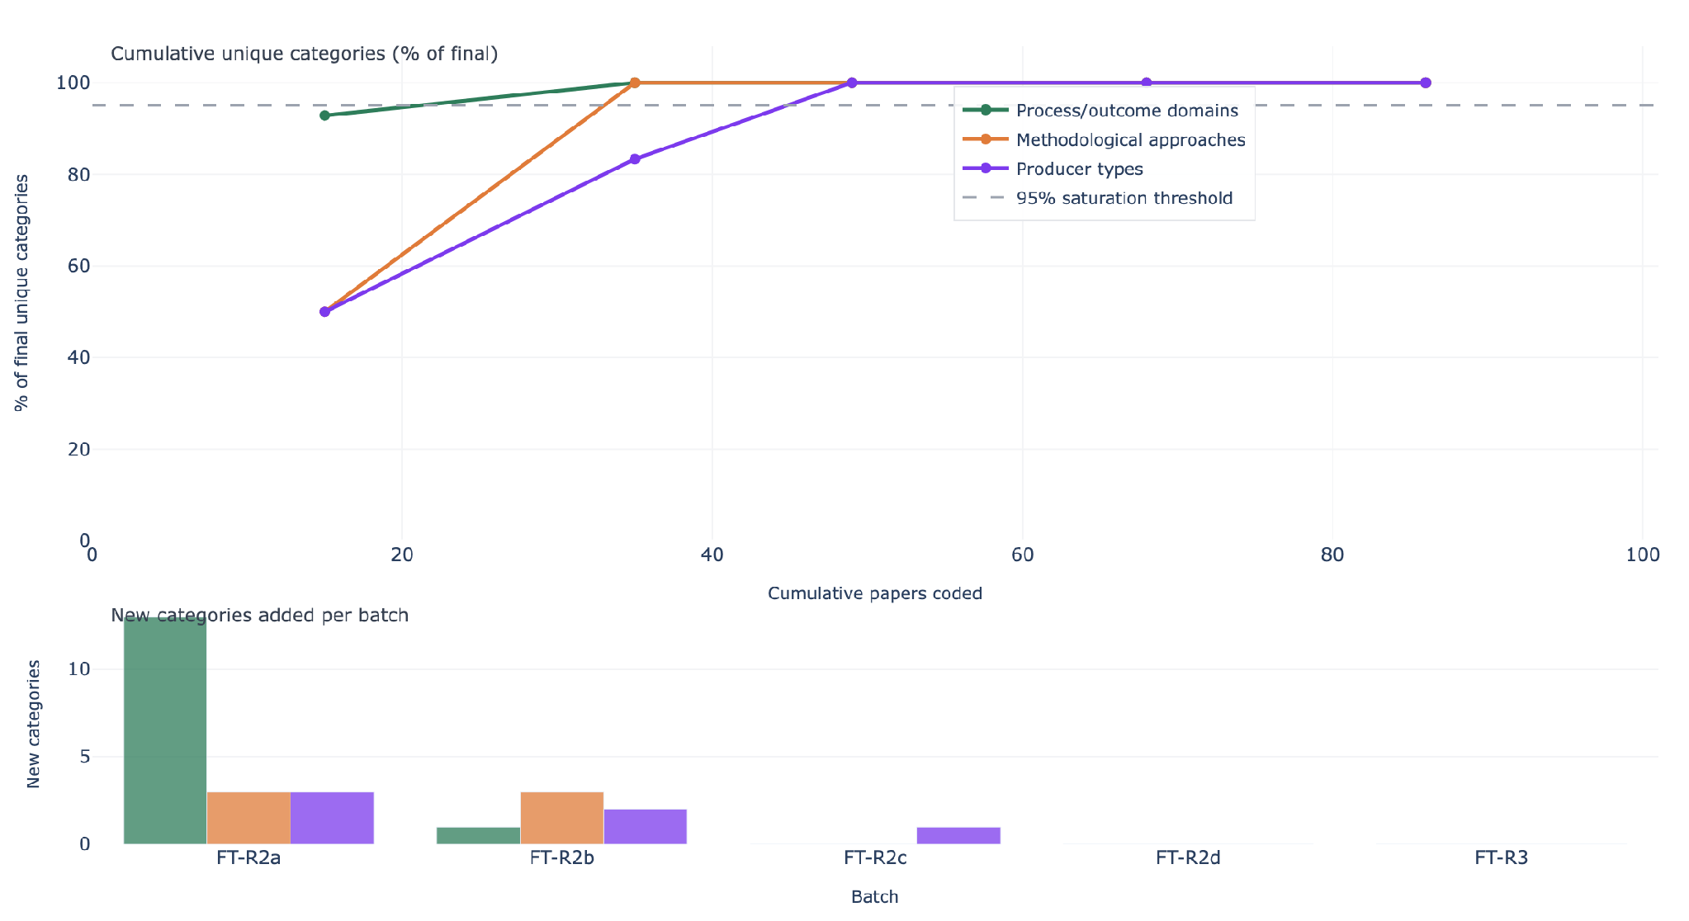
Figure 8. Information saturation curve. Top: cumulative unique categories as % of final total by papers coded. Bottom: new categories per batch. All dimensions plateau by 49 papers.

4.7 Temporal and geographic patterns
Figure 9 shows how research focus has shifted over time. Process domains, particularly knowledge and awareness (51 studies), decision-making and planning (40), and uptake and adoption (41), dominate across all three periods and have grown substantially since 2020. Outcome domains remain sparse in absolute terms, though resilience and adaptive capacity has grown from 6 studies before 2015 to 38 since 2020, suggesting a gradual shift toward measuring impact rather than just process.
Figure 10 shows how producer type coverage varies by region. Crop farmer studies dominate in every region. Sub-Saharan Africa has the most diverse coverage, with 22 crop farmer studies and 13 livestock studies. Fisheries/aquaculture and agroforestry are nearly absent from MENA and Latin America, with zero studies in most cells. This confirms that the producer bias seen in the evidence gap map is consistent across regions and not driven by any single geography.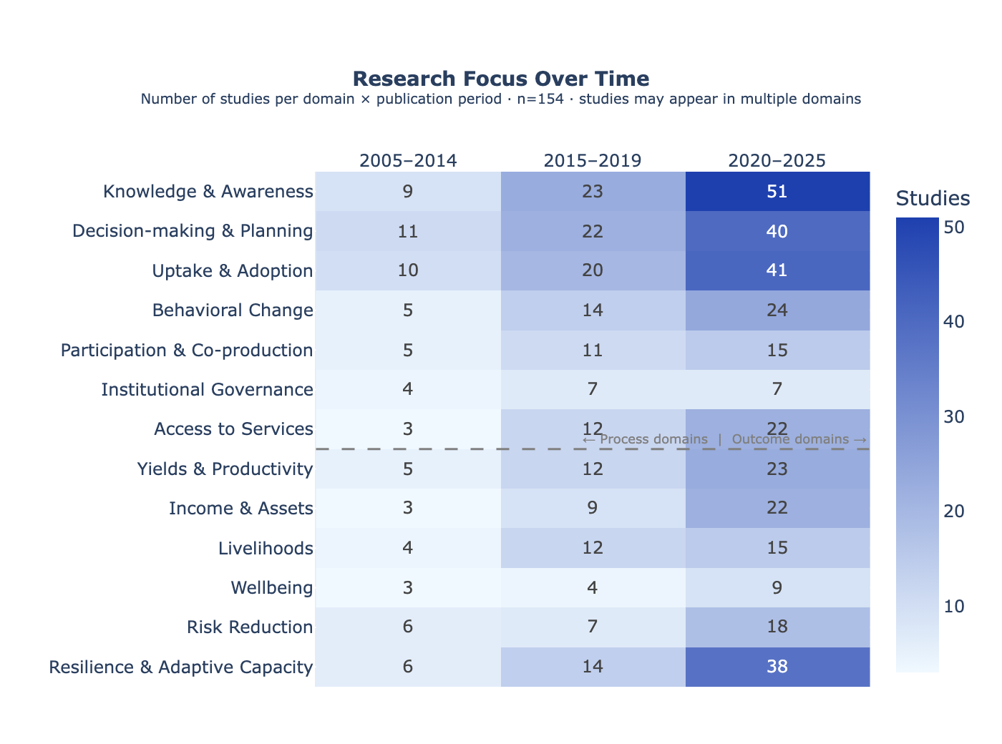
Figure 9. Research focus by publication period. Rows = process/outcome domains; columns = publication period. Cell values = number of studies. Studies may appear in multiple domains.
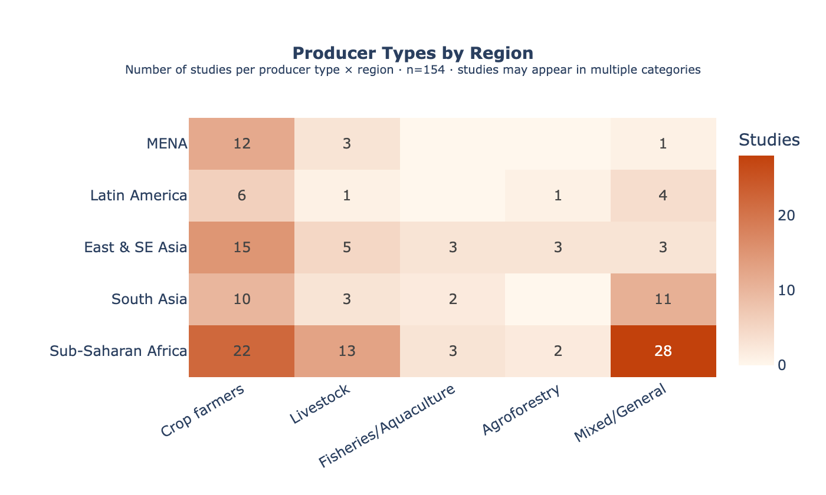
Figure 10. Producer type coverage by region. Rows = region; columns = producer type. Cell values = number of studies. Blank cells = no studies.

5. Searchable Database
- An interactive evidence gap map is available at https://main.d3a9jahzuu7xai.amplifyapp.com/systematic-map#evidence-gap-map
- A searchable database of all included studies is available at https://main.d3a9jahzuu7xai.amplifyapp.com/systematic-map#searchable-database
- All code and data: [Zenodo DOI — to be assigned upon final release]

6. Conclusions
The evidence gap map reveals a systematic mismatch between what adaptation M&E currently measures and what is needed to understand adaptation effectiveness.
- Process-oriented outcomes are well-documented, impact-oriented outcomes are not. The literature reliably captures whether farmers adopted a practice or gained knowledge. It almost never measures whether adaptation improved incomes, wellbeing, or resilience.
- Non-crop producer types are almost entirely unmeasured. Livestock, fisheries, agroforestry, and mixed-system producers appear in very few cells of the evidence map. Most are pure gaps.
- Geographic concentration limits generalisability. Three countries account for 22% of all studies. The evidence base cannot support regional conclusions across most LMICs.
- The equity gap is the most critical for policy. 38% of studies make no reference to any marginalized group; of the 60% that do, coverage is almost entirely limited to women and youth. Disability, ethnicity, age, and land tenure appear in 5% or fewer of studies each. We cannot tell whether adaptation is reaching the most vulnerable populations.
- A lack of robust experimental evidence limits causal inference. While cross-sectional quantitative and qualitative methods are abundant, rigorous experimental designs are exceptionally rare. This makes it difficult to definitively prove whether specific capacity-building or adaptation interventions actually cause improvements in long-term resilience, rather than merely showing correlations with practice adoption.
Addressing these gaps requires investment in long-term cohort studies, equity-disaggregated data collection, and research that targets non-crop livelihood systems. A follow-on systematic review is planned to build on this evidence map.

7. Acknowledgements
This work was funded by the International Livestock Research Institute (ILRI) under the CGIAR Initiative on Climate Resilience (ClimBeR). The authors thank the ILRI project team for their guidance and stakeholder engagement support throughout the protocol development and screening process. The systematic map protocol was peer-reviewed by an independent Methods Advisor and informed by feedback from the CGIAR and ILRI stakeholder network.

8. References
- Bristlepine Resilience Consultants (2026). Deliverable 3: Final Systematic Map Protocol — Measuring what matters: tracking climate adaptation processes and outcomes for smallholder producers in the agriculture sector. January 2026, v3. Zenodo. https://doi.org/10.5281/zenodo.19811629
- Collaboration for Environmental Evidence (2018). Guidelines and Standards for Evidence Synthesis in Environmental Management. Version 5.1. Pullin AS, Frampton GK, Livoreil B, Petrokofsky G (eds). https://www.environmentalevidence.org/guidelines
- Haddaway, N.R., Macura, B., Whaley, P. and Pullin, A.S. (2018). ROSES Reporting standards for Systematic Evidence Syntheses: pro forma, flow diagram and descriptive summary of the plan and conduct of environmental systematic reviews and systematic maps. Environmental Evidence, 7, 7. https://doi.org/10.1186/s13750-018-0121-7

